Parcel 9

110 Twelfth St N, City of Olean

|  |  |  |  |  |  |  |  |  |  |  |  |
| --- | --- | --- | --- | --- | --- | --- | --- | --- | --- | --- | --- |
| http://maps.cattco.org/imate/quickstream.aspx?file=VOLLOCAL/Rel2017/041200094064000607400000000004.jpg&thumb=true&width=201&height=152 | | | | | | **Status:** | | | Active | | |
| **Roll Section:** | | | Taxable | | |
| **Swis:** | | | 041200 | | |
| **Tax Map ID #:** | | | 94.064-6-74 | | |
| **Property Class:** | | | 210 - 1 Family Res | | |
| **Site:** | | | RES 1 | | |
| **In Ag. District:** | | | No | | |
| **Site Property Class:** | | | 210 - 1 Family Res | | |
| **Zoning Code:** | | | - | | |
| **Neighborhood Code:** | | | 12204 | | |
| **Total Acreage/Size:** | | | 30 x 101.7 | | | **School District:** | | | Olean | | |
| **Land Assessment:** | | | 2017 - $2,400 | | | **Total Assessment:** | | | 2017 - $17,000 | | |
| **Full Market Value:** | | | 2017 - $19,101 | | |  | | |  | | |
| **Living Area:** | | 1,774 sq. ft. | | | **First Story Area:** | | | | 1,071 sq. ft. | |
| **Second Story Area:** | | 703 sq. ft. | | | **Half Story Area:** | | | | 0 sq. ft. | |
| **Finished Basement:** | | 0 sq. ft. | | | **Number of Stories:** | | | | 2 | |
| **Building Style:** | | Old style | | | **Bathrooms (Full - Half):** | | | | 2 - 0 | |
| **Bedrooms:** | | 3 | | | **Kitchens:** | | | | 1 | |
| **Fireplaces:** | | 0 | | | **Basement Type:** | | | | Partial | |
| **Overall Condition:** | | Poor | | | **Overall Grade:** | | | | Economy | |
| **Year Built:** | | 1940 | | |  | | |  | | |
| **Structure** | **Size** | | | **Grade** | | | **Condition** | | | **Year** | | |
| Shed-aluminum | 8 × 10 | | | Average | | | Poor | | | 1970 | | |
| User defined | **MINIMUM BID $2500**  [Type a quote from the document or the summary of an interesting point. You can position the text box anywhere in the document. Use the Drawing Tools tab to change the formatting of the pull quote text box.] | | | Average | | | Fair | | | 1970 | | |

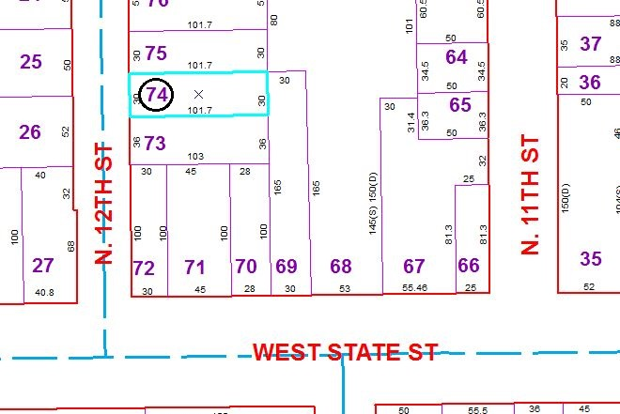

Approximate Yearly Taxes

School $444

City $248

County $238

Total $930

Special Districts for 2015