Parcel 374

Bone Run Rd, Town of South Valley

|  |  |  |  |  |
| --- | --- | --- | --- | --- |
| *No Photo Available* | | **Status:** | Active | |
| **Roll Section:** | Taxable | |
| **Swis:** | 048200 | |
| **Tax Map ID #:** | 97.002-1-24 | |
| **Property Class:** | 314 - Rural vac<10 | |
| **Site:** | RES 1 | |
| **In Ag. District:** | No | |
| **Site Property Class:** | 314 - Rural vac<10 | |
| **Zoning Code:** | - | |
| **Neighborhood Code:** | 82350 | |
| **Total Acreage/Size:** | 1.97 | **School District:** | Randolph | |
| **Land Assessment:** | 2017 - $4,800 | **Total Assessment:** | 2017 - $4,800 | |
| **Full Market Value:** | 2017 - $6,761  Approximate Yearly Taxes  School $67  Town/County $103  Total $170 |  |  |

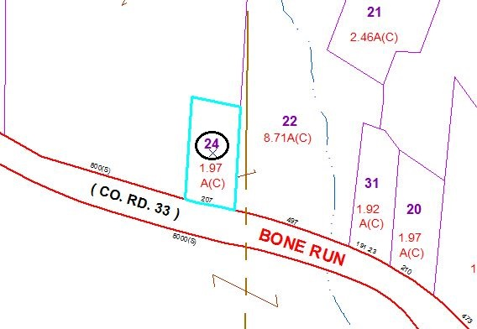

Special Districts for 2015