Parcel 364

28 Sheldon St, Town of Randolph

|  |  |  |  |  |  |  |  |  |  |  |  |  |  |
| --- | --- | --- | --- | --- | --- | --- | --- | --- | --- | --- | --- | --- | --- |
| http://maps.cattco.org/imate/quickstream.aspx?file=VOLLOCAL/Rel2017/047600070071000202000000000004.jpg&thumb=true&width=201&height=152 | | | | | | **Status:** | | | | Active | | | |
| **Roll Section:** | | | | Taxable | | | |
| **Swis:** | | | | 047600 | | | |
| **Tax Map ID #:** | | | | 70.071-2-20 | | | |
| **Property Class:** | | | | 210 - 1 Family Res | | | |
| **Site:** | | | | RES 1 | | | |
| **In Ag. District:** | | | | No | | | |
| **Site Property Class:** | | | | 210 - 1 Family Res | | | |
| **Zoning Code:** | | | | - | | | |
| **Neighborhood Code:** | | | | 76010 | | | |
| **Total Acreage/Size:** | | | 50 x 99.2 | | | **School District:** | | | | Randolph | | | |
| **Land Assessment:** | | | 2017 - $3,300 | | | **Total Assessment:** | | | | 2017 - $25,000 | | | |
| **Full Market Value:** | | | 2017 - $31,646 | | |  | | | |  | | | |
| **Living Area:** | | 1,436 sq. ft. | | | **First Story Area:** | | | | | | 752 sq. ft. | | | |
| **Second Story Area:** | | 480 sq. ft. | | | **Half Story Area:** | | | | | | 0 sq. ft. | | | |
| **Additional Story Area:** | | 0 sq. ft. | | | **3/4 Story Area:** | | | | | | 204 sq. ft. | | | |
| **Finished Basement:** | | 0 sq. ft. | | | **Number of Stories:** | | | | | | 2 | | | |
| **Building Style:** | | Old style | | | **Bathrooms (Full - Half):** | | | | | | 1 - 0 | | | |
| **Bedrooms:** | | 3 | | | **Kitchens:** | | | | | | 1 | | | |
| **Fireplaces:** | | 0 | | | **Basement Type:** | | | | | | Partial | | | |
| **Porch Type:** | | Porch-covered | | | **Porch Area:** | | | | | | 98.00 | | | |
| **Overall Condition:** | | Normal | | | **Overall Grade:** | | | | | | Average | | | |
| **Year Built:** | | 1890 | | |  | | | |  | | | |
| **Structure** | **Size** | | | **Grade** | | | **Condition** | **Year** | | | |
| Porch-covered | 7 × 14 | | | Average | | | Normal | 1960 | | | |
| Carport | 12 × 16 | | | Average | | | Normal | 1960 | | | |
| Gar-1.0 detached | 12 × 18 | | | Average | | | Normal | 1940 | | | |
| Porch-enclosed | 50.00 sq. ft.  Approximate Yearly Taxes  School $313  Town/County $751  Total $1,064 | | | Average | | | Normal | 1940 | | | |

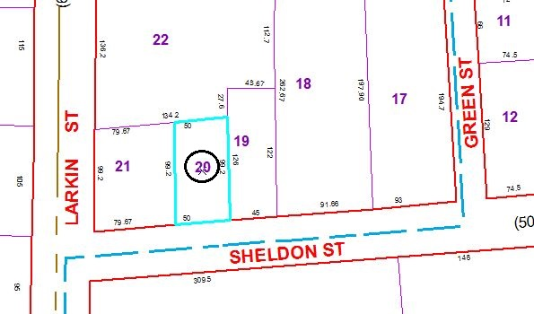

Special Districts for 2015