Parcel 353

1350 Portville Olean Rd, Town of Portville

|  |  |  |  |  |  |  |  |  |  |  |
| --- | --- | --- | --- | --- | --- | --- | --- | --- | --- | --- |
|  | | | | **Status:** | | | Active | | | |
| **Roll Section:** | | | Taxable | | | |
| **Swis:** | | | 047489 | | | |
| **Tax Map ID #:** | | | 104.005-1-7 | | | |
| **Property Class:** | | | 210 - 1 Family Res | | | |
| **Site:** | | | RES 1 | | | |
| **In Ag. District:** | | | No | | | |
| **Site Property Class:** | | | 210 - 1 Family Res | | | |
| **Zoning Code:** | | | CON - CONFORMING | | | |
| **Neighborhood Code:** | | | 74050 | | | |
| **Total Acreage/Size:** | | 62 x 231 | | **School District:** | | | Portville | | | |
| **Land Assessment:** | | 2017 - $7,500 | | **Total Assessment:** | | | 2017 - $27,000 | | | |
| **Full Market Value:** | | 2017 - $28,421 | |  | | |  | | |
| **Living Area:** | | 1,802 sq. ft. | | **First Story Area:** | | | | 1,064 sq. ft. | |
| **Second Story Area:** | | 738 sq. ft. | | **Half Story Area:** | | | | 0 sq. ft. | |
| **Finished Basement:** | | 0 sq. ft. | | **Number of Stories:** | | | | 2 | |
| **Building Style:** | | Old style | | **Bathrooms (Full - Half):** | | | | 2 - 0 | |
| **Bedrooms:** | | 3 | | **Kitchens:** | | | | 1 | |
| **Fireplaces:** | | 0 | | **Basement Type:** | | | | Partial | |
| **Porch Type:** | | Porch-covered | | **Porch Area:** | | | | 321.00 | |
| **Overall Condition:** | | Poor | | **Overall Grade:** | | | | Average | |
| **Year Built:** | | 1920 | |  | | |  | | |
| **Structure** | **Size** | | **Grade** | | **Condition** | **Year** | | |
| Porch-covered | 321.00 sq. ft.  Approximate Yearly Taxes  School $623  Town/County $465  Total $1,088 | | Average | | Poor | 1920 | | |

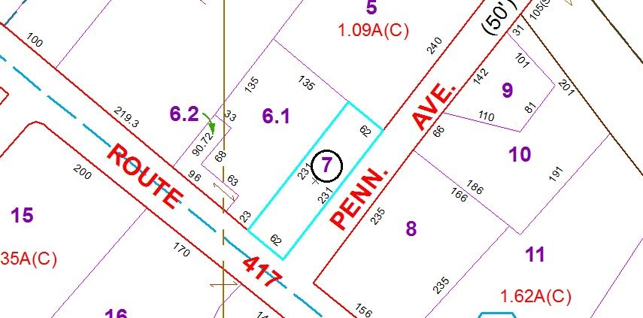

Special Districts for 2015