Parcel 326

8960 Aust Rd, Town of Otto

|  |  |  |  |  |  |  |  |  |  |
| --- | --- | --- | --- | --- | --- | --- | --- | --- | --- |
| *See county website*  *For picture* | | | | **Status:** | | | Active | | |
| **Roll Section:** | | | Taxable | | |
| **Swis:** | | | 046800 | | |
| **Tax Map ID #:** | | | 27.001-1-14 | | |
| **Property Class:** | | | 270 – Mfg. housing | | |
| **Site:** | | | RES 1 | | |
| **In Ag. District:** | | | No | | |
| **Site Property Class:** | | | 270 – Mfg. housing | | |
| **Zoning Code:** | | | 01 | | |
| **Neighborhood Code:** | | | 68050 | | |
| **Total Acreage/Size:** | | 2.78 | | **School District:** | | | Cattaraugus - Little Valley | | |
| **Land Assessment:** | | 2017 - $4,400 | | **Total Assessment:** | | | 2017 - $11,000 | | |
| **Full Market Value:** | | 2017 - $11,000 | |  | | |  | |
| **Year Built:** | | 1970 | |  | | |  | |
| **Structure** | **Size** | | **Grade** | | **Condition** | **Year** | |
| Cabin/bungalow | 14 × 6 | | Minimum | | Normal | 1975 | |
| Mobile home | 70 × 12  Approximate Yearly Taxes  School $161  Town/County $274  Total $435 | | Economy | | Poor | 1970 | |

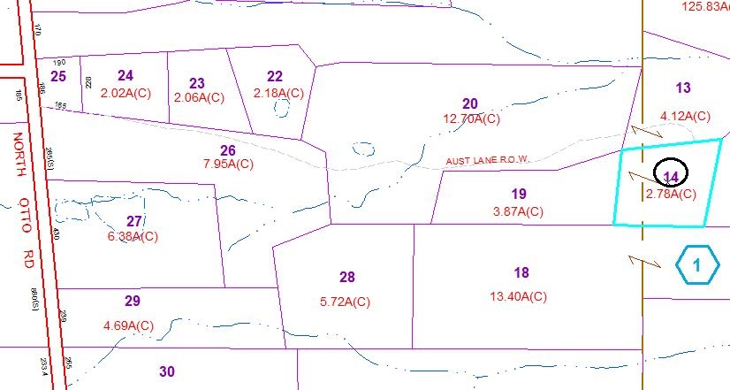

Special Districts for 2015