Parcel 312

2650 Wildcat Rd, Town of Olean

|  |  |  |  |  |  |  |  |  |  |
| --- | --- | --- | --- | --- | --- | --- | --- | --- | --- |
| http://maps.cattco.org/imate/quickstream.aspx?file=VOLLOCAL/Rel2017/046600103001000305500200000003.jpg&thumb=true&width=201&height=152 | | | | **Status:** | | | Active | | |
| **Roll Section:** | | | Taxable | | |
| **Swis:** | | | 046600 | | |
| **Tax Map ID #:** | | | 103.001-3-55.2 | | |
| **Property Class:** | | | 210 - 1 Family Res | | |
| **Site:** | | | RES 1 | | |
| **In Ag. District:** | | | No | | |
| **Site Property Class:** | | | 210 - 1 Family Res | | |
| **Zoning Code:** | | | - | | |
| **Neighborhood Code:** | | | 66350 | | |
| **Total Acreage/Size:** | | 1.25 | | **School District:** | | | Olean | | |
| **Land Assessment:** | | 2017 - $4,200 | | **Total Assessment:** | | | 2017 - $15,500 | | |
| **Full Market Value:** | | 2017 - $20,130 | |  | | |  | | |
| **Living Area:** | | 792 sq. ft. | | **First Story Area:** | | | | 792 sq. ft. | |
| **Finished Basement:** | | 0 sq. ft. | | **Number of Stories:** | | | | 1 | |
| **Building Style:** | | Cottage | | **Bathrooms (Full - Half):** | | | | 1 - 0 | |
| **Bedrooms:** | | 2 | | **Kitchens:** | | | | 1 | |
| **Fireplaces:** | | 0 | | **Basement Type:** | | | | Slab/pier | |
| **Porch Type:** | | Porch-open/deck | | **Porch Area:** | | | | 84.00 | |
| **Overall Condition:** | | Fair | | **Overall Grade:** | | | | Economy | |
| **Year Built:** | | 1920 | |  | | |  | | |
| **Structure** | **Size** | | **Grade** | | **Condition** | **Year** | | |
| Porch-open/deck | 7 × 12 | | Minimum | | Fair | 1920 | | |
| Porch-covered | 119.00 sq. ft. | | Average | | Normal | 1920 | | |

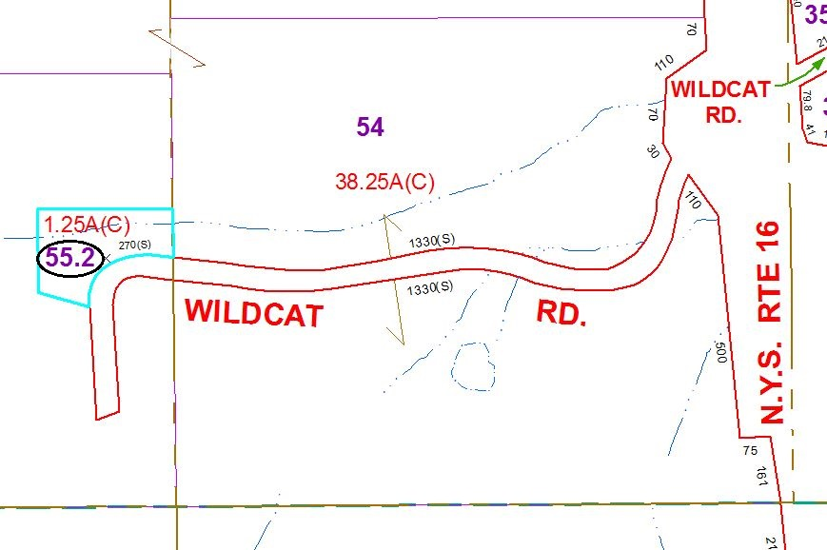

Approximate Yearly Taxes

School $478

Town/County $350

Total $828

Special Districts for 2015