Parcel 159

11457 First St, Town of Dayton

|  |  |  |  |  |  |  |  |  |  |  |  |  |  |
| --- | --- | --- | --- | --- | --- | --- | --- | --- | --- | --- | --- | --- | --- |
| http://maps.cattco.org/imate/quickstream.aspx?file=VOLLOCAL/Rel2017/043089016018000300500100000005.jpg&thumb=true&width=201&height=152 | | | | | | **Status:** | | | Active | | | | |
| **Roll Section:** | | | Taxable | | | | |
| **Swis:** | | | 043089 | | | | |
| **Tax Map ID #:** | | | 16.018-3-5.1 | | | | |
| **Property Class:** | | | 210 - 1 Family Res | | | | |
| **Site:** | | | RES 1 | | | | |
| **In Ag. District:** | | | No | | | | |
| **Site Property Class:** | | | 210 - 1 Family Res | | | | |
| **Zoning Code:** | | | - | | | | |
| **Neighborhood Code:** | | | 30050 | | | | |
| **Total Acreage/Size:** | | | 0.63 | | | **School District:** | | | Gowanda | | | | |
| **Land Assessment:** | | | 2017 - $3,600 | | | **Total Assessment:** | | | 2017 - $58,100 | | | | |
| **Full Market Value:** | | | 2017 - $58,100 | | |  | | |  | | | | |
| **Living Area:** | | 1,892 sq. ft. | | | **First Story Area:** | | | | | | 1,048 sq. ft. | |
| **Second Story Area:** | | 844 sq. ft. | | | **Half Story Area:** | | | | | | 0 sq. ft. | |
| **Finished Basement:** | | 0 sq. ft. | | | **Number of Stories:** | | | | | | 2 | |
| **Building Style:** | | Old style | | | **Bathrooms (Full - Half):** | | | | | | 1 - 0 | |
| **Bedrooms:** | | 4 | | | **Kitchens:** | | | | | | 1 | |
| **Fireplaces:** | | 0 | | | **Basement Type:** | | | | | | Partial | |
| **Porch Type:** | | Porch-covered | | | **Porch Area:** | | | | | | 192.00 | |
| **Overall Condition:** | | Fair | | | **Overall Grade:** | | | | | | Average | |
| **Year Built:** | | 1890 | | |  | | |  | | | | |
| **Structure** | **Size** | | | **Grade** | | | **Condition** | | | **Year** | |
| Porch-covered | 24 × 8 | | | Economy | | | Poor | | | 1900 | |
| Porch-covered | 24 × 6 | | | Economy | | | Fair | | | 1900 | |
| Porch-enclosed | 16 × 5 | | | Minimum | | | Poor | | | 1900 | |
| Barn-2.0 gen | 24 × 18 | | | Average | | | Fair | | | 1900 | |
| Shed-machine | 17 x 12 | | | Average | | | Poor | | | 1900 | |

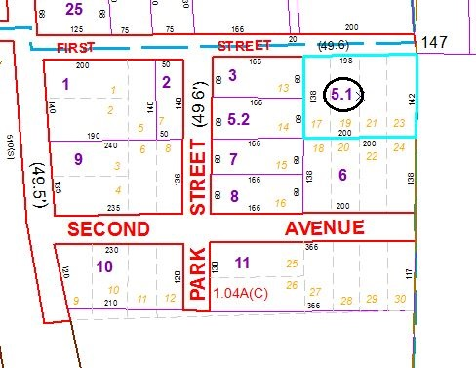

Approximate Yearly Taxes

School $1,056

Town/County $1,169

Total $2,225

Special Districts for 2015