Parcel 150

227 Mill St, Village of South Dayton

|  |  |  |  |  |  |  |  |  |
| --- | --- | --- | --- | --- | --- | --- | --- | --- |
| http://maps.cattco.org/imate/quickstream.aspx?file=VOLLOCAL/Rel2017/043001033034000101600000000011.jpg&thumb=true&width=201&height=152 | | | | **Status:** | | Active | | |
| **Roll Section:** | | Taxable | | |
| **Swis:** | | 043001 | | |
| **Tax Map ID #:** | | 33.034-1-16 | | |
| **Property Class:** | | 210 - 1 Family Res | | |
| **Site:** | | RES 1 | | |
| **In Ag. District:** | | No | | |
| **Site Property Class:** | | 210 - 1 Family Res | | |
| **Zoning Code:** | | - | | |
| **Neighborhood Code:** | | 30080 | | |
| **Total Acreage/Size:** | | 116.1 x 220 | | **School District:** | | Pine Valley | | |
| **Land Assessment:** | | 2017 - $5,600 | | **Total Assessment:** | | 2017 - $27,000 | | |
| **Full Market Value:** | | 2017 - $27,000 | |  | |  | | |
| **Living Area:** | | 1,075 sq. ft. | | **First Story Area:** | | | 1,075 sq. ft. | |
| **Building Style:** | | Old style | | **Bathrooms (Full - Half):** | | | 1 - 0 | |
| **Bedrooms:** | | 3 | | **Kitchens:** | | | 1 | |
| **Fireplaces:** | | 0 | | **Basement Type:** | | | Crawl | |
| **Porch Type:** | | Porch-covered | | **Porch Area:** | | | 175.00 | |
| **Basement Garage Cap:** | | 0 | | **Attached Garage Cap:** | | | 888.00 sq. ft. | |
| **Overall Condition:** | | Fair | | **Overall Grade:** | | | Economy | |
| **Year Built:** | | 1906 | |  | |  | | |
| **Structure** | **Size** | | **Grade** | | **Condition** | | **Year** |
| Gar-1.0 attached | 37 × 24 | | Average | | Fair | | 1920 |
| Shed-machine | 37 × 10 | | Minimum | | Fair | | 1920 |
| Porch-covered | 25 × 7 | | Minimum | | Fair | | 1982 |

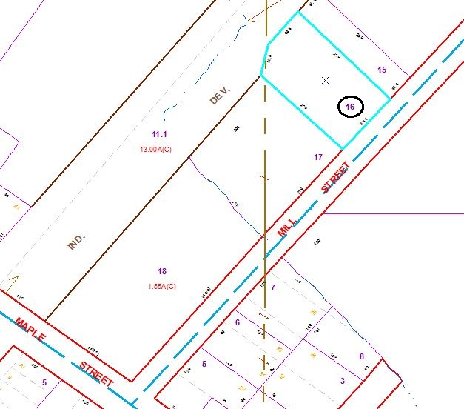

Approximate Yearly Taxes

School $596

Village $349

Town/County $510

Total $1,455

Special Districts for 2015