Parcel 110

Gooseneck Rd, Town of Ashford

|  |  |  |  |
| --- | --- | --- | --- |
| *No Photo Available* | | **Status:** | Active |
| **Roll Section:** | Taxable |
| **Swis:** | 042200 |
| **Tax Map ID #:** | 20.002-3-30 |
| **Property Class:** | 323 - Vacant rural |
| **Site:** | RES 1 |
| **In Ag. District:** | No |
| **Site Property Class:** | 323 - Vacant rural |
| **Zoning Code:** | - |
| **Neighborhood Code:** | 22010 |
| **Total Acreage/Size:** | 80 x 110 | **School District:** | West Valley |
| **Land Assessment:** | 2017 - $500 | **Total Assessment:** | 2017 - $500 |
| **Full Market Value:** | 2017 - $926 |  |  |

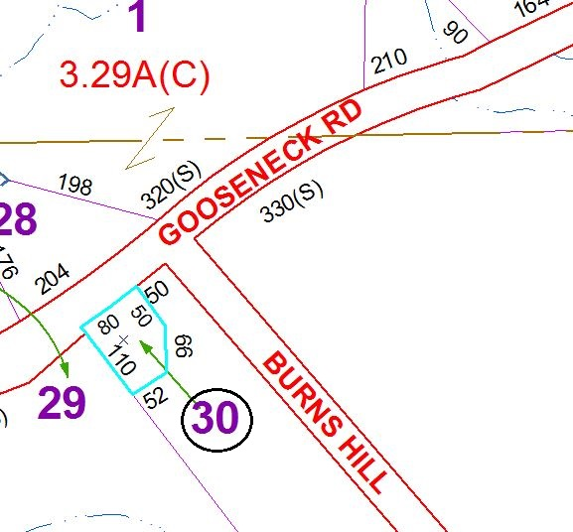

Approximate Yearly Taxes

School $18

Town/County $16

Total $34

Special Districts for 2015